AI-Driven OCR & Image Recognition Automation
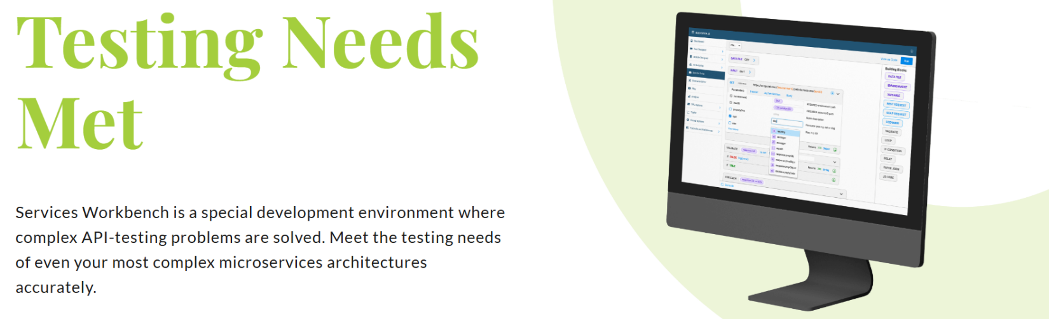

My role: Technical Product Manager / AI Systems Lead
Project description:
Led the development and coordination of AI-driven automation capabilities including OCR and image recognition to improve software testing efficiency, reliability, and scalability. Collaborated across engineering, QA, and product teams to define requirements, prioritize delivery, and support enterprise automation initiatives. Contributed to reducing manual testing effort, improving validation workflows, accelerating release cycles, and enhancing overall system reliability in complex SaaS environments.
Skills and deliverables
- Artificial Intelligence
- Test Automation
- Software Testing
- AI Product Management
- Agile Software Development

